A PROJECT REPORT

R.K jewellery Shop

Submitted by

Prajapati Ketulkumar Sureshbhai(24032010100036)
Barot Jayrajkumar Rakeshkumar(24032010100004)

In fulfillment for the award of the degree Of
MASTER OF COMPUTER APPLICATION



Department of Computer Application (MCA)
Sankalchand Patel College of Engineering Sankalchand Patel University, Visnagar

April, 2026

Department of Computer Application (MCA)
Sankalchand Patel College of Engineering Sankalchand Patel University, Visnagar

CERTIFICATE
Date:

This is to certify that the Project entitled R.K jewelry Shop has been carried out by Prajapati Ketul Suresh Bhai(24032010100036) and Barot Jayrajkumar Rakeshkumar(24032010100004) under the guidance of Ms. Vandana G Patel (ASST. Prof) Internal Guide in fulfillment of the degree of Master of Computer Application of Sankalchand Patel University, Vinegar during the academic year 2025-26.

Prof. Vandana G. Patel | Dr. Jitendra H. Darji  Prof. Piyush A. Patel | Dr. Tulsidas V. Nakarani
Internal Guide | Coordinator | HOD

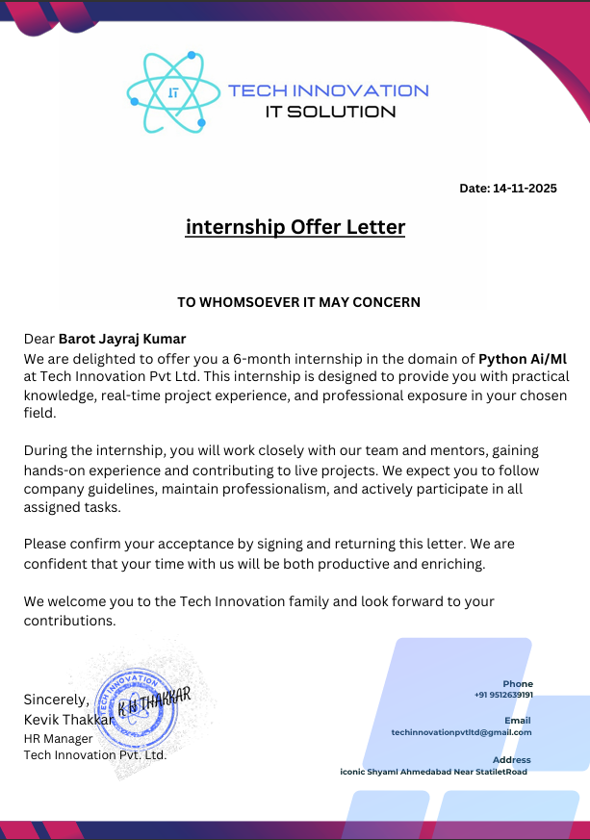


ACKNOWLEDGEMENT

We wish to express our heartfelt appreciation to all those who have contributed to this project, both explicitly and implicitly. Without the cooperation of whom, it would not have been possible to complete this project.

We would like to specially thanks PROF. Vandana G Patel of SPCE MCA College, Visnagar and all other faculty members for their timely help and guidance, as without their guidance, it would have been difficult to collect the detail of project and problem faced during development of project.

Your Faithfully
Prajapati Ketul Sureshbhai
Barot Jayraj Rakeshkuma

ABSTRACT

In the dynamic world of modern retail, the R.K Jewellery Shop Management System emerges as a comprehensive and efficient solution designed to simplify and streamline business operations. Our system is a powerful platform developed using Python, dedicated to managing sales, inventory, and customer interactions with accuracy, security, and reliability. It serves as a centralized hub where customers, staff, and administrators can seamlessly interact within a structured digital environment.

The R.K Jewellery Shop Management System acts as a technological backbone for the business, offering organized modules to manage product inventory, customer records, billing processes, order tracking, and sales reports. Much like a well-coordinated ecosystem, the system integrates various operational components into one unified platform, ensuring smooth communication and data flow across departments. Whether handling daily sales transactions, updating stock levels, or managing customer purchases, the system enhances productivity while reducing manual effort.

Beyond simple record maintenance, the platform emphasizes automation, transparency, and role-based access control. Administrators can efficiently oversee shop operations, staff members can manage customer interactions and billing, and business owners can monitor performance through detailed reports. The system also supports structured data storage through a secure database, ensuring data integrity and minimizing errors associated with traditional paper-based methods.

Navigating the R.K Jewellery Shop Management System is intuitive and user-friendly, providing a seamless experience for both technical and non-technical users. Built with scalability in mind, the platform allows future enhancements such as online ordering, customer loyalty programs, digital payment integration, SMS/WhatsApp notifications, and advanced analytics.

Welcome to the R.K Jewellery Shop Management System – where technology meets tradition to create an organized, transparent, and efficient retail experience.

LIST OF TABLES

Table No | Table Description | Page No
1 | USER TABLE | 15
2 | CATEGORY TABLE | 16
3 | PRODUCT TABLE | 16
4 | CART TABLE | 17
5 | CART ITEM TABLE | 17
6 | ORDER TABLE | 18
7 | ORDER ITEM TABLE | 18
8 | PAYMENT TABLE | 19
9 | ADRESS TABLE | 19
10 | PROFILE TABLE | 20

LIST OF FIGURES
Figure No | Figure Description | Page No
1 | SYATEM DESIGN diagram
2 | E-R Diagram | 24
3 | Use Case Diagram | 26
4 | Class Diagram | 29
5 | Activity Diagram (Admin) | 32
6 | Activity Diagram (User) | 35
7 | Sequence Diagram | 37
8 | State Diagram (Admin)
9 | State Diagram (User)
10 | Deployment Diagram | 38

Symbol Name | Abbreviations
UML | Unified Modeling Language
ER | Entity Relationship
DB | Database
PK | Primary Key
FK | Foreign Key
CMP | College Management Project
HTML | Hypertext Markup Language
CSS | Cascading Style Sheets
JS | JavaScript
SQL | Structured Query Language
API | Application Programming Interface
CRUD | Create, Read, Update, Delete
UI | User Interface
IDE | Integrated Development Environment

TABLE OF CONTENTS
 | Acknowledgement |  |  | I
 | Abstract |  |  | II
 | List of Figures |  |  | III
 | List of Tables |  |  | IV
 | List of Abbreviations |  |  | V
Chapter1 | Introduction |  |  | 1
 | 1.1 | Project Profile |  | 2
 | 1.2 | Organization Profile |  | 3
Chapter 2 | Requirement Specification |  |  | 4
 | 2.1 | Existing System Study |  | 5
 | 2.2 | Need for the New System |  | 5
 | 2.3 | Objective of the New System |  | 5
 | 2.4 | Time line Chart |  | 6
Chapter 3 | Functional Specifications |  |  | 7
 | 3.1 | Introduction |  | 8
 |  | 3.1.1 | Purpose | 8
 |  | 3.1.2 | Scope | 8
 | 3.2 | General Description |  | 8
 |  | 3.2.1 | Functional Description | 9
 |  | 3.2.2 | User Characteristics | 10
 |  | 3.2.3 | General Constraints | 11
Chapter 4 | Hardware & Software Specification |  |  | 12
 | 4.1 | Hardware Requirement |  | 13
 | 4.2 | Software Requirement |  | 13
Chapter 5 | Detailed Design |  |  | 14
 | 5.1 | Data Dictionary |  | 15
 | 5. 2 | Entity Relationship Diagram |  | 24
 | 5. 13 | UML Diagrams |  | 26

Chapter 6 | Input & Output Design |  | 42
 | 6.1 | Input Design | 41
 | 6.2 | Output Design | 45
Chapter 7 | Implementation Methodology |  | 62
 | 7.1 | Front- end Description | 63
 | 7.2 | Back- end Description | 64
Chapter 8 | Testing & Results |  | 65
 | 8.1 | Introduction | 66
 | 8.2 | Test Cases | 68
 | 8.3 | Screen Shots | 69
Chapter 9 | Limitations & Future Scope |  | 71
 | 9.1 | Limitations | 72
 | 9.2 | Future Scope | 72
Chapter 10 | Conclusion |  | 73
Chapter 11 | References |  | 75

CHAPTER 1
INTRODUCTION

  - Project Profile
Project Title | R.K jewellery Shop Project
Project Definition | The R.K Jewellery Shop Management System is a web-based application developed using Python and Django to automate retail and administrative operations of a jewellery business, including managing product inventory, customer records, billing, orders, and sales transactions through a centralized and secure database. The system is designed to reduce manual work, improve operational efficiency, and provide a user-friendly digital platform for effective shop management, ensuring accuracy, faster processing, and enhanced customer service by integrating all business activities into a single, streamlined system.
Objective | To develop a centralized system that stores and manages all jewellery shop-related data such as product inventory, customer details, staff records, billing, orders, and sales transactions, reducing paperwork and data redundancy.
External Project Guide | Mr. Dhruv Makwana
Internal Project Guide | Ms. Vandana G Patel (ASST. Prof)
Team Size | 2
Team Member | Barot Jayraj Rakeshkuma  Prajapati Ketul Sureshbhai
Front End Tool | Html, CSS, JS, Bootstrap
Back End Tool | Python, Django, SQL Lite Database
Report Generation Tools | Microsoft Word 2021, Microsoft Power Point 2021
Operating System | Windows 11
Project Duration | 6 Months

  - Organization Profile

    - Tech Innovation Pvt ltd is a forward-thinking IT solutions and software development organization dedicated to delivering innovative digital services. The company focuses on custom web and mobile application development, UI/UX design, Python and full-stack solutions, digital marketing, and comprehensive online internship/training programs. Their approach blends creativity, technical expertise, and client-centric methodology to build scalable technology products and support businesses in achieving digital transformation.
    - Contact Number: +91 9512639191

    - Address: Iconic Shyamal, Near Satellite Road, Ahmedabad, Gujarat, India
    - Company Website: www.techinnovationit.in

    - Email: techinnovationpvtltd@gmail.com

CHAPTER2

REQUIREMENT SPECIFICATION

  - Existing System

⮚ Most shop operations such as inventory tracking, billing, and customer record management are handled manually.
⮚ Maintaining records in registers or paper files leads to duplicate entries and data inconsistency.
⮚ Searching for product details or customer purchase history is slow and inefficient.
⮚ Manual systems consume a lot of time and increase workload for shop staff and management.
⮚ There is a high possibility of human errors in billing, stock calculations, and transaction records.
⮚ Manual records are not secure and may be lost or damaged due to misplacement or lack of proper backup.
2.2 ​Need For New System
⮚ To automate daily shop operations such as billing, inventory management, and customer record handling, reducing manual effort.
⮚ To ensure accurate and real-time tracking of jewellery stock, minimizing errors in stock calculation and preventing losses.
⮚ To provide a fast and efficient way to generate bills and manage sales transactions.
⮚ To improve data organization and eliminate redundancy by maintaining records in a centralized database.
⮚ To enhance security of business data with proper backup and access control mechanisms.
⮚ To enable quick access to customer purchase history and product details for better customer service.
⮚ To reduce workload on staff and improve overall productivity of the shop.
⮚ To support future enhancements such as online orders, digital payments, and customer notification systems..
2.3 ​Objective Of New System

The R.K Jewellery Shop Management System aims to automate and centralize shop operations for better
efficiency. It helps maintain accurate inventory records and simplifies billing and sales processes. The system stores customer details and purchase history, reduces manual work and errors, ensures data security, and provides real-time reports with a user-friendly interface.

2.4 Timeline Chart

Months | December |  | January |  |  |  | February |  |  |  | March |  |  |  | April
Week | 3 | 4 | 1 | 2 | 3 | 4 | 1 | 2 | 3 | 4 | 1 | 2 | 3 | 4 | 1 | 2
Definition
System Analysis
Database design
Diagram Design
Documentation

CHAPTER :3
FUNCTION SPECIFICATION

  - Introduction

The R.K Jewellery Shop Management System is a web-based application developed using Python and Django to automate and manage the daily operations of a jewellery shop. It provides a centralized platform to handle inventory, billing, customer records, and sales activities efficiently. The system aims to improve accuracy, reduce manual work, and ensure smooth business operations through digital management.

    - Purpose
- To develop a centralized online Jewellery Shop Management System.
- The main goal is to reduce manual work and save time by managing all shop operations digitally.
- To automate billing, inventory tracking, and customer management processes.
- To improve efficiency, accuracy, and overall productivity of the jewellery business.

    - Scope
- The objective of this application is to develop a system that effectively manages all data related to jewellery products, customers, staff, sales, and billing processes within the shop.
- The purpose is to maintain a centralized database of all business and transactional information.
- The system supports various functions such as inventory management, sales tracking, customer handling, and report generation.
- The goal is to manage shop operations efficiently, securely, and transparently with minimal manual effort.

3.2General Description
The R.K Jewellery Shop Management System is a web-based application developed using Python and the Django framework to automate and manage various retail and administrative activities of a jewellery shop. The system provides a centralized platform where Admin, Staff, and Customers can access and manage information according to their roles.
The Admin can manage product inventory, staff details, pricing, and generate sales reports. Staff members can handle billing, manage customer transactions, update stock details, and assist in daily operations. Customers can view product details, check purchase history, and receive billing information through a secure system.
The system ensures role-based access control, data security, and efficient record management. It reduces manual paperwork, minimizes human errors, improves transparency, and enhances the overall operational efficiency of the jewellery business.

3.2.1Functional Description

      - Windows 11
          - Windows 11 is the latest major release of Microsoft's Windows NT operating system, released in October 2021. It is a free upgrade to its predecessor, Windows 10 (2015), available for any Windows 10 devices that meet the new Windows 11 system requirements.
          - Windows 11 features major changes to the Windows shell influenced by the cancelled Windows 10X, including a redesigned Start menu, the replacement of its "live tiles" with a separate "Widgets" panel on the taskbar, the ability to create tiled sets of windows that can be minimized and restored from the taskbar as a group, and new gaming technologies inherited from Xbox Series X and Series S such as Auto HDR and Direct Storage on compatible hardware. Internet Explorer (IE) has been replaced by the Chromium- based Microsoft Edge as the default web browser like its predecessor. Windows 10, and Microsoft Teams is integrated into the Windows shell. Microsoft also announced plans to allow more flexibility in software that can be distributed via Microsoft Store, and to support Android apps on Windows 11112] (including a partnership with Amazon to make its app store available for the function).
          - Windows 11 has received a widely polarized reception. Pre-release coverage of the operating system focused on its stricter hardware
          - requirements, with discussions over whether they were legitimately intended to improve the security of Windows

3.2.2User Characteristics

• Nowadays, to reduce manual work and save time, retail businesses like jewellery shops are shifting towards digital management systems. The traditional paper-based system is time-consuming, error-prone, and difficult to manage.
• The R.K Jewellery Shop Management System (RKJSMS) helps in automating retail and administrative activities such as inventory management, billing, customer records, sales tracking, and notifications.
• This system saves time for Admin and Staff while improving customer service. It allows users to access information quickly and efficiently.
• The application contains the following modules:
- Admin
- Customer

3.2.3 General Constraints

❖ Role and Activities Performed by the Admin
⮚ Admin can add, update, and delete jewellery products (gold, silver, diamond, etc.).
⮚ Admin can manage product categories and pricing details.
⮚ Admin can manage staff details and roles.
⮚ Admin can view and manage all customer records.
⮚ Admin can monitor inventory levels and stock availability.
⮚ Admin can generate sales and financial reports.
⮚ Admin can send notifications or offers to customers.
⮚ Admin can manage orders and transactions.

❖ Role and Activities Performed by the Customer
⮚ Customer can view jewellery products and details.
⮚ Customer can check purchase history and billing information.
⮚ Customer can place orders or make purchases.
⮚ Customer can update profile information.
⮚ Customer can receive notifications about offers and updates.

CHAPTER:4
HARDWARE & SOFTWARE SPECIFICATION

Server Side: -
Server Side: -
  - 4.1 Hardware (Recommended)

- RAM: 8 GB
- Processer: AMD Ryzen 5 5600H with Radeon Graphics
- Hard Disk: 512 GB SSD
User Side: -
  - 4.1 Hardware (Recommended)

- Processer: Dual Core Processor or Above
- RAM: 2GB
- Hard Disk: 250GB
- Hardware Requirement

Server Side:-
  - 4.2 Software (Recommended)
- Front end
  - Front End Tool: Django Templates.
  - Supporting Tools: Bootstrap 5
  - Designing: HTML, CSS, JavaScript
- Back end
  - Server: Django Development Server
  - Database: SQLite.
- Operation System

  - Windows 7 to Windows 11

CHAPTER 5

DETAILSDESIGN

5.1 Data Dictionary

Table No: - 01
Table name: - User Table
Purpose: Handles user registration, login, and authentication
- Description: Stores user and admin account details
- Primary Key: id
- Foreign Key: —
- Unique Key: email

Field Name | Data Type | Description | Constraints
id | int | Unique user ID | Primary Key
email_verification_status | Bit | Email verification status | Not Null
otp | int | OTP number | Not Null
otp_time | datetime | OTP generated time | Not Null
email | varchar | User email | Unique
name | varchar | User name | Not Null
password | varchar | User password | Not Null
role | varchar | Role (Admin/User) | Not Null

Table No: - 02
Table name: - CATEGORY Table
- Description: Stores jewellery product categories such as Ring, Necklace, Earrings, etc. It helps in organizing products in the R.K system.
- Primary Key: category_id
- Foreign Key: —
- Unique Key: category_name

Field Name | Data Type | Description | Constraint
category_id | INT | Unique ID for each category | PRIMARY KEY, AUTO_INCREMENT
category_name | VARCHAR | Name of category (e.g., Ring, Necklace) | NOT NULL
description | VARCHAR | Short description of category | NULL
status | ENUM('Active','Inactive') | Category status | DEFAULT 'Active'
created_at | DATETIME | Record creation date | DEFAULT CURRENT_TIMESTAMP
updated_at | DATETIME | Last updated date | ON UPDATE CURRENT_TIMESTAMP

Table No: - 03
Table name: - PRODUCT TABLE
Purpose: Manages jewellery items available for sale
- Description: Stores product details
- Primary Key: product_id
- Foreign Key: —
- Unique Key: —

Field Name | Data Type | Description | Constraints
product_id | int | Unique product ID | Primary Key
name | varchar | Product name | Not Null
category | varchar | Jewellery category | Not Null
price | float | Product price | Not Null
stock | int | Available stock | Not Null
description | varchar | Product description | —
image | varchar | Product image | —

Table No: - 04
Table name: - CART TABLE
Purpose: Stores items selected by user before purchase
- Description: Temporary cart storage
- Primary Key: cart_id
- Foreign Key: user_id, product_id
- Unique Key: —

Field Name | Data Type | Description | Constraints
cart_id | int | Cart ID | Primary Key
user_id | int | Reference to user | Foreign Key
product_id | int | Reference to product | Foreign Key
quantity | int | Quantity | Not Null

Table No: - 05
Table name: - Order Table
Purpose: Handles order processing and tracking
- Description: Stores order information
- Primary Key: order_id
- Foreign Key: user_id
- Unique Key: —

Field Name | Data Type | Description | Constraints
order_id | int | Order ID | Primary Key
user_id | int | User reference | Foreign Key
total_price | float | Total price | Not Null
status | varchar | Order status | Not Null
order_date | datetime | Order date | Not Null

Table No: - 06
Table name: - ORDER TABLE
Purpose: Stores detailed product information per order
- Description: Products inside each order
- Primary Key: order_details_id
- Foreign Key: order_id, product_id
- Unique Key: —

Field Name | Data Type | Description | Constraints
order_details_id | int | Unique ID | Primary Key
order_id | int | Order reference | Foreign Key
product_id | int | Product reference | Foreign Key
quantity | int | Quantity | Not Null
price | float | Product price | Not Null

Table No: - 07
Table name: - Payment Table
Purpose: Manages transaction details
- Description: Stores payment information
- Primary Key: payment_id
- Foreign Key: order_id
- Unique Key: —

Field Name | Data Type | Description | Constraints
payment_id | int | Payment ID | Primary Key
order_id | int | Order reference | Foreign Key
amount | float | Payment amount | Not Null
method | varchar | Payment method | Not Null
status | varchar | Payment status | Not Null
payment_date | datetime | Payment date | Not Null

Table No: - 08
Table name: - Address Module
Purpose: Stores delivery addresses
- Description: User address details
- Primary Key: address_id
- Foreign Key: user_id
- Unique Key: —

Field Name | Data Type | Description | Constraints
address_id | int | Address ID | Primary Key
user_id | int | User reference | Foreign Key
address | varchar | Full address | Not Null
city | varchar | City | Not Null
state | varchar | State | Not Null
pincode | int | Pincode | Not Null

Table No: - 09
Table name: - PROFILE TABLE
- Purpose: Store user (admin/staff) account details
- Description: Contains login credentials and personal information of users who manage the jewellery shop system
- Primary Key: profile_id
- Foreign Key: — (Not required)

- Field Name | - Data Type | - Constraints | - Description
- profile_id | - INT | - PRIMARY KEY, AUTO_INCREMENT | - Unique user ID
- full_name | - VARCHAR(100) | - NOT NULL | - Name of the user
- username | - VARCHAR(50) | - NOT NULL, UNIQUE | - Login username
- password | - VARCHAR(255) | - NOT NULL | - User password
- email | - VARCHAR(100) | - UNIQUE | - Email address
- phone_number | - VARCHAR(15) | - UNIQUE | - Contact number
- address | - TEXT | - NULL | - User address
- role | - ENUM('admin','staff') | - NOT NULL, DEFAULT 'staff' | - User role
- created_at | - TIMESTAMP | - DEFAULT CURRENT_TIMESTAMP | - Account creation time
- updated_at | - TIMESTAMP | - DEFAULT CURRENT_TIMESTAMP ON UPDATE CURRENT_TIMESTAMP | - Last update time

  - E-R Diagram

An Entity Relationship (ER) Diagram is a type of flowchart that illustrates how “entities” such as people, objects or concepts relate to each other within a system. ER Diagrams are most often used to design or debug relational databases in the fields of software engineering, business information systems, education and research. Also known as ERDs or ER Models, they use a defined set of symbols such as rectangles, diamonds, ovals and connecting lines to depict the interconnectedness of entities, relationships and their attributes. They mirror grammatical structure, with entities as nouns and relationships as verbs.

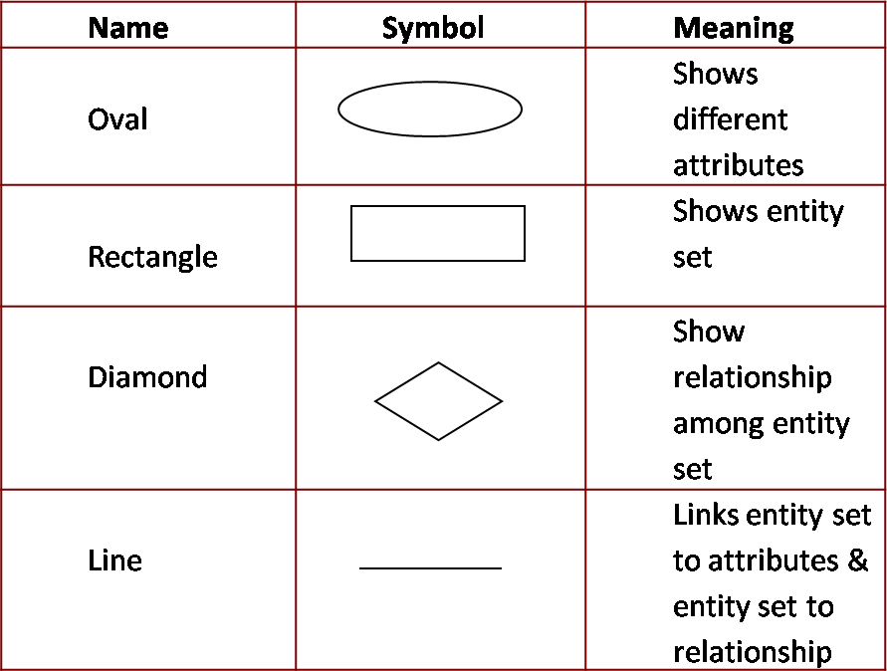

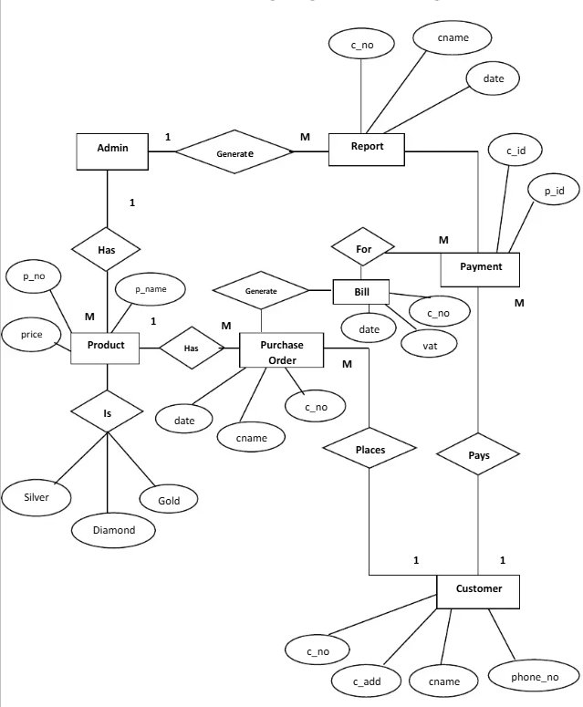
Figure 5.17

  - UML Diagram

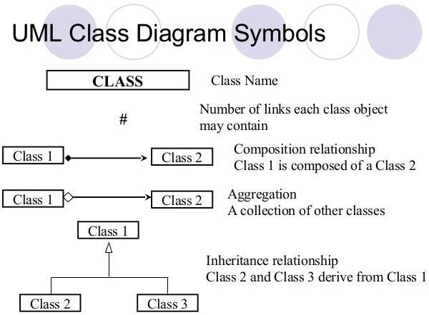

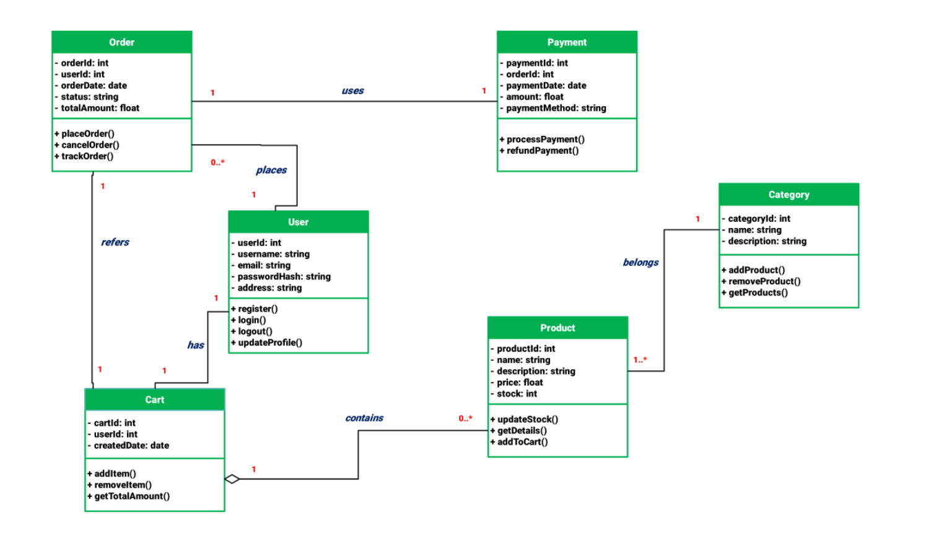

    - ​Use Case Diagram

      - A UML use case diagram is the primary form of system/software requirements for a new software program underdeveloped.
      - Use cases specify the expected behavior (what), and not the exact method of making it happen (how).
      - Use cases once specified can be denoted both textual and visual representation (i.e. use case diagram).
      - A key concept of use case modeling is that it helps us design a system from the end user's perspective.
      - It is an effective technique for communicating system behavior in the user's terms by specifying all externally visible system behavior.

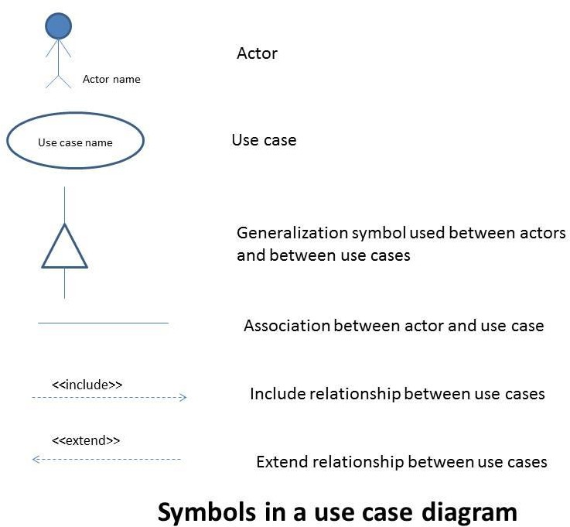

- Admin and User-

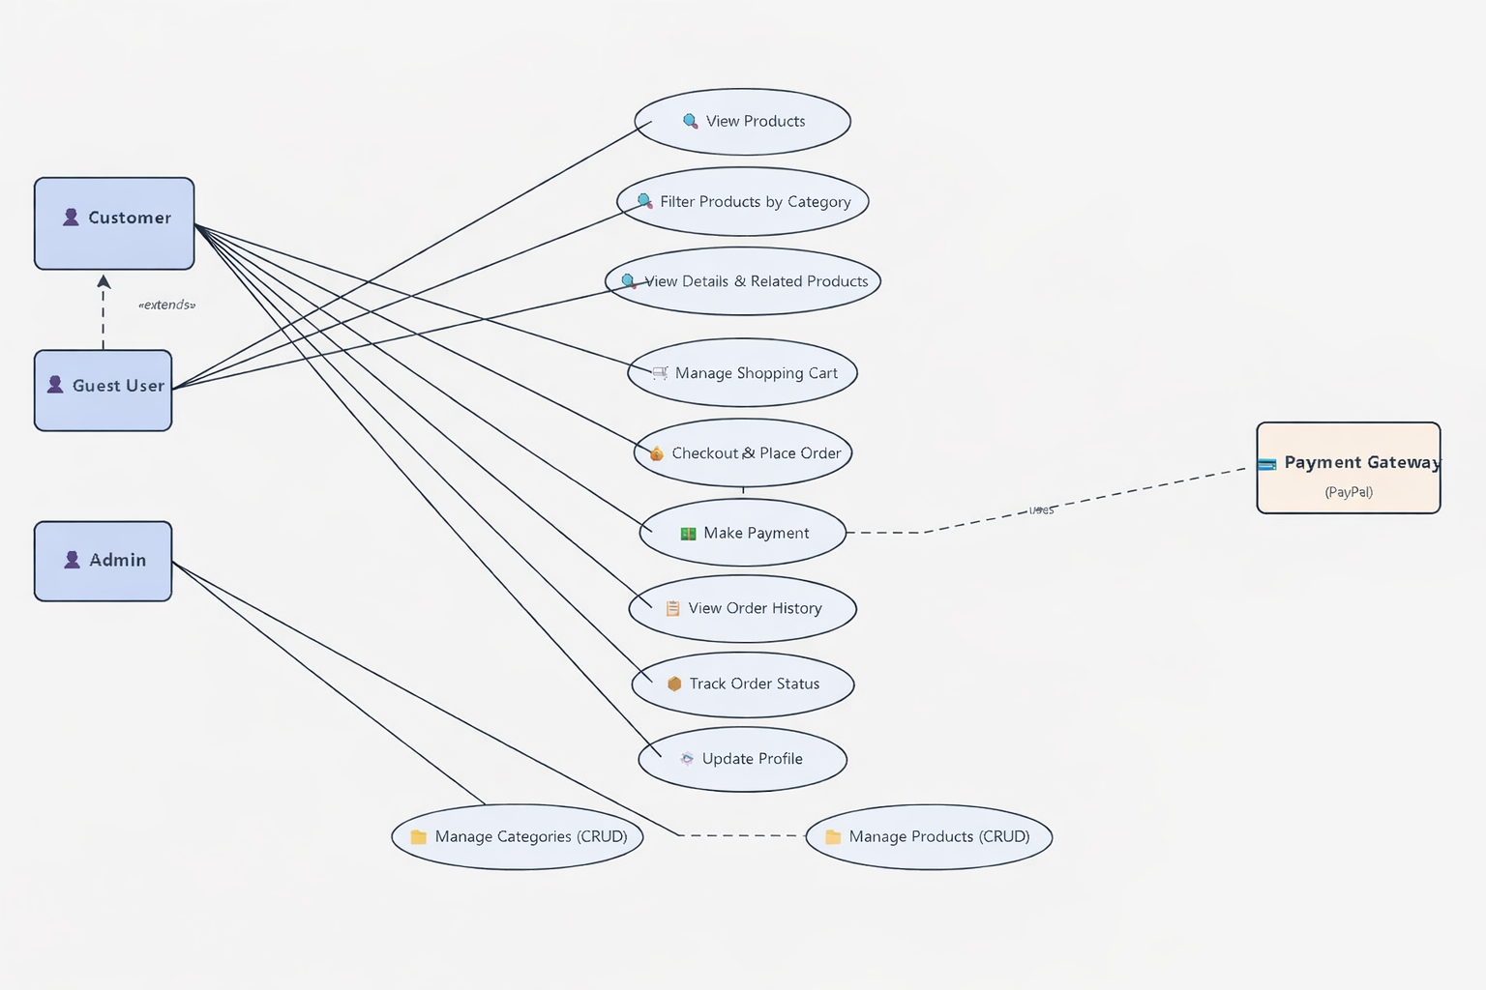

Figure 5.19

    - Sequence Diagram

      - Sequence Diagrams are interaction diagrams that detail how operations are carried out. They capture the interaction between objects in the context of a collaboration. Sequence Diagrams are time focus and they show the order of the interaction visually by using the vertical axis of the diagram to represent time what messages are sent and when.

- User, website And Admin

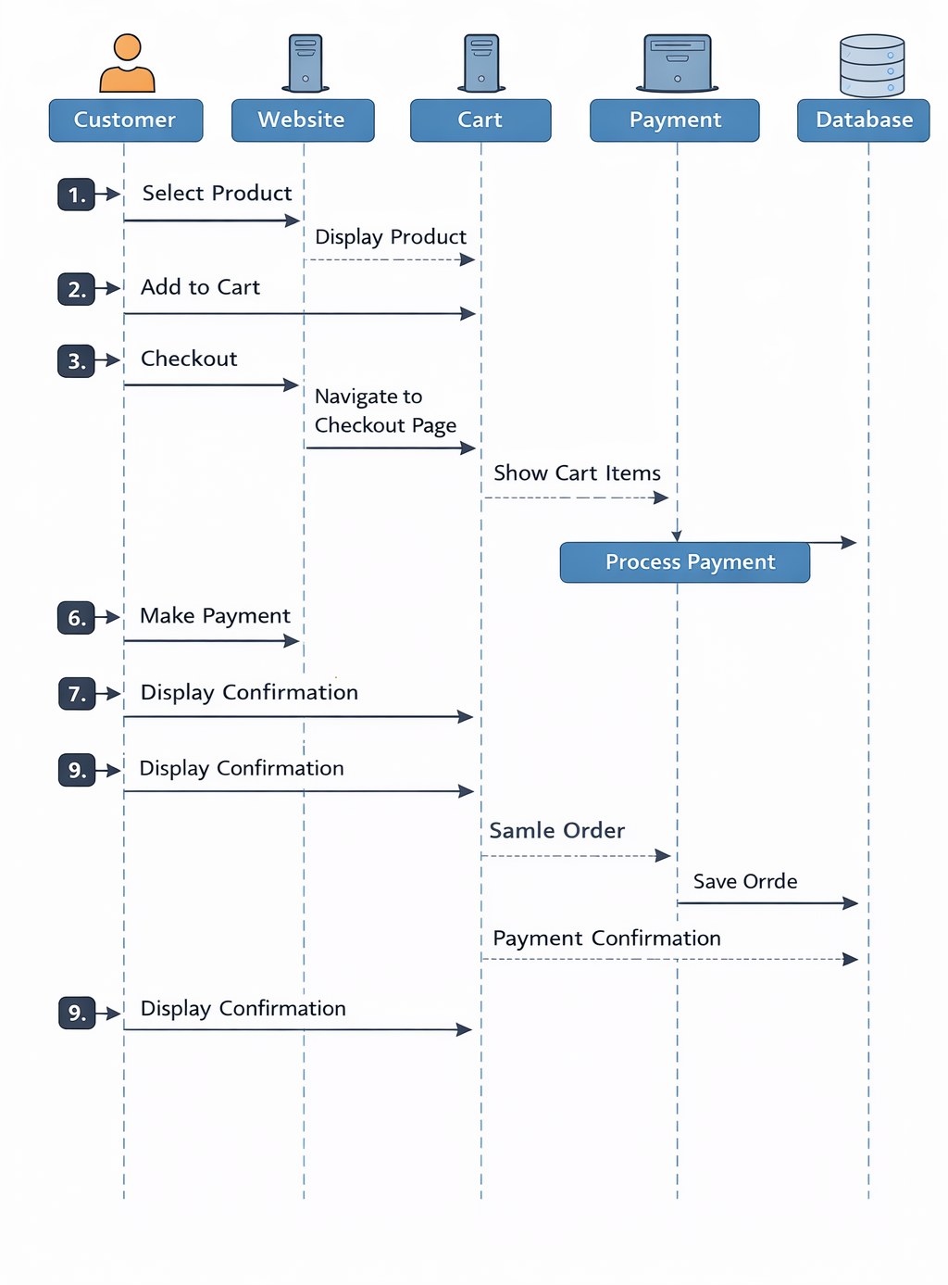

    - ​Activity Diagram

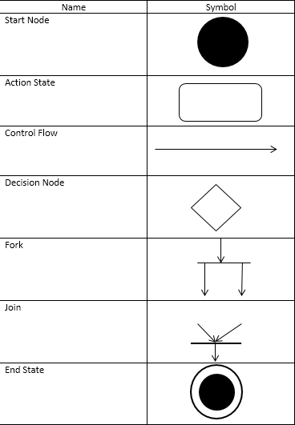
      - Activity diagram is another important behavioral diagram in UML diagram to describe dynamic aspects of the system. Activity diagram is essentially an advanced version of flow chart that modeling the flow from one activity to another activity.

Admin Activity Diagram:-

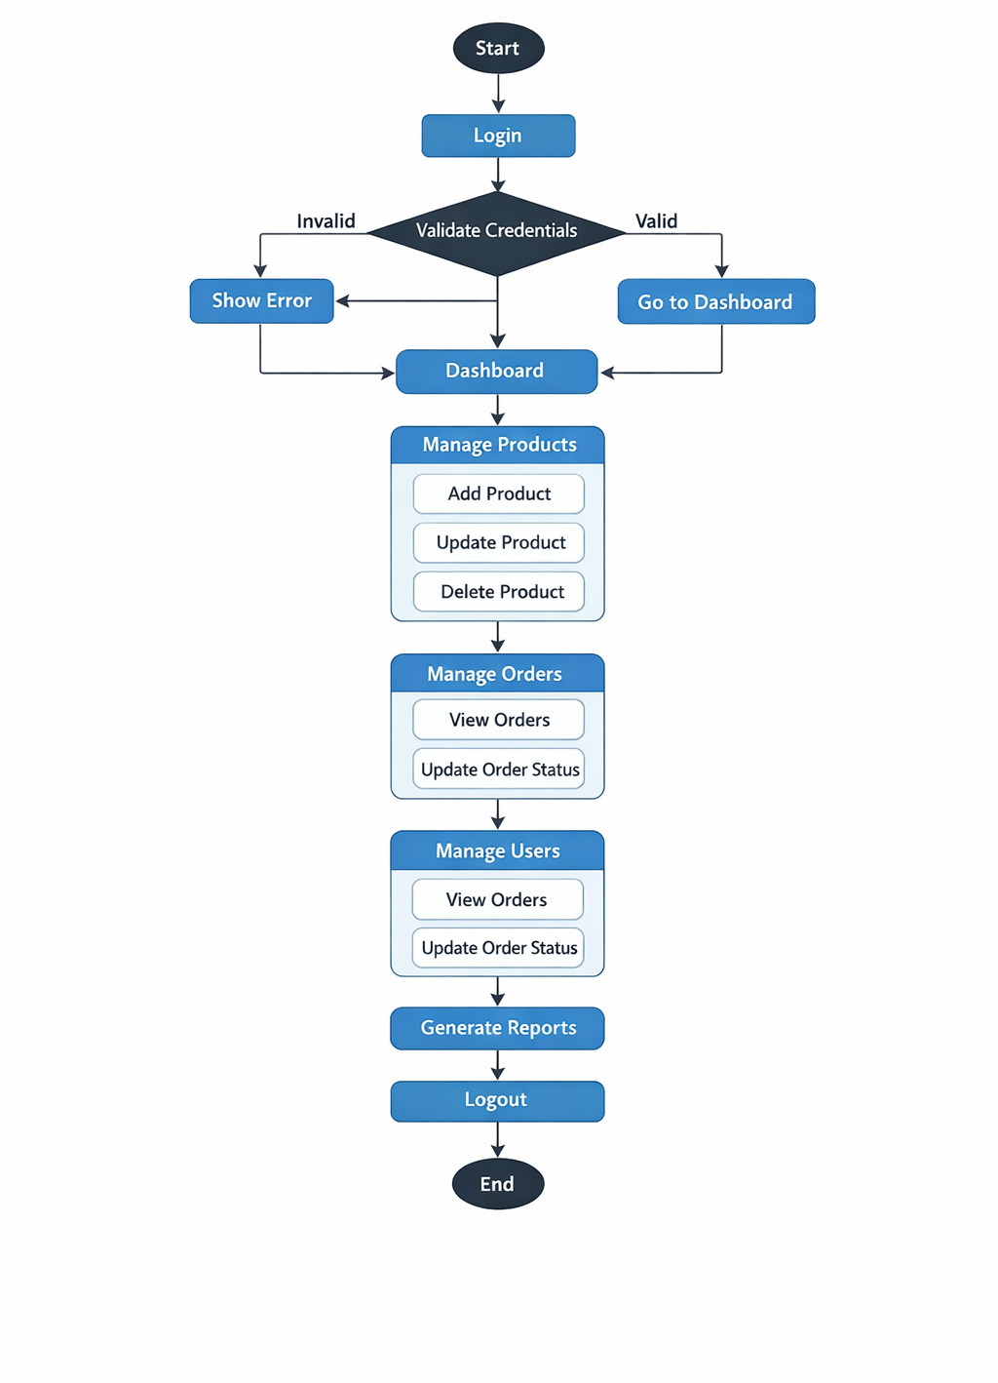

User Activity Diagram:-

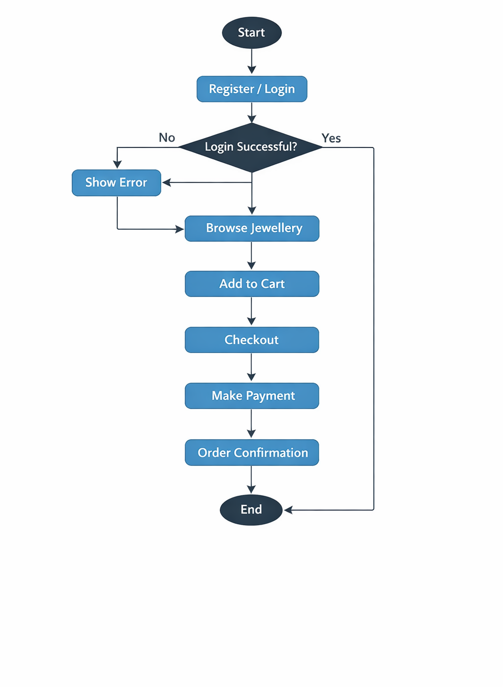

Deployment Diagram:-

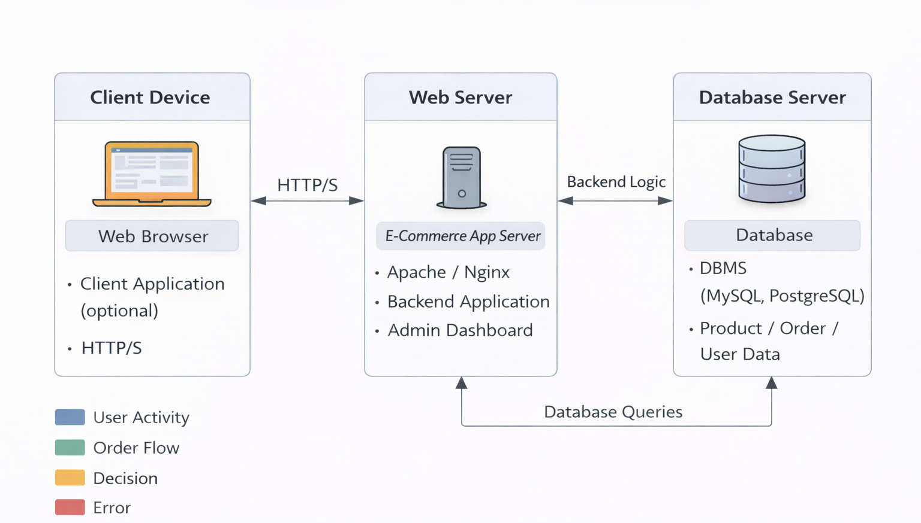

State Diagram(Admin):-
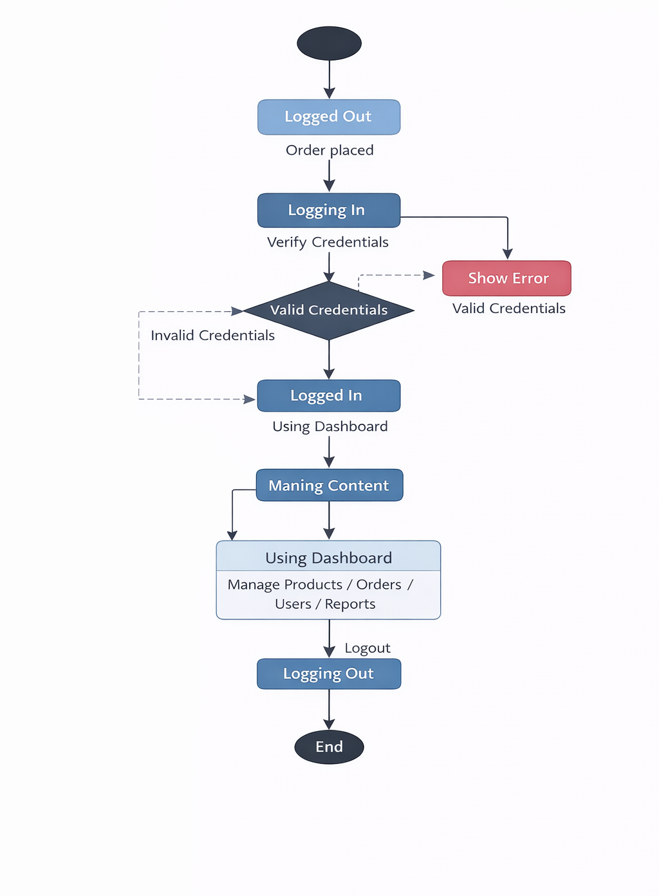

State Diagram(User):-
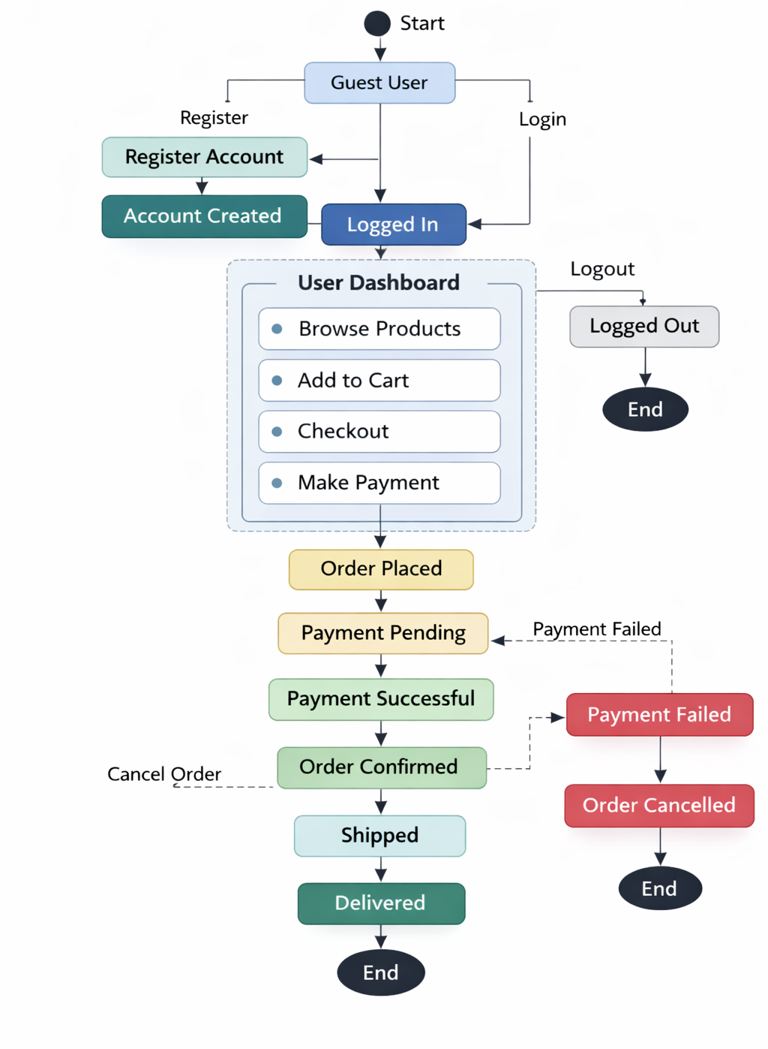

R.K Jewellery shop state diagram

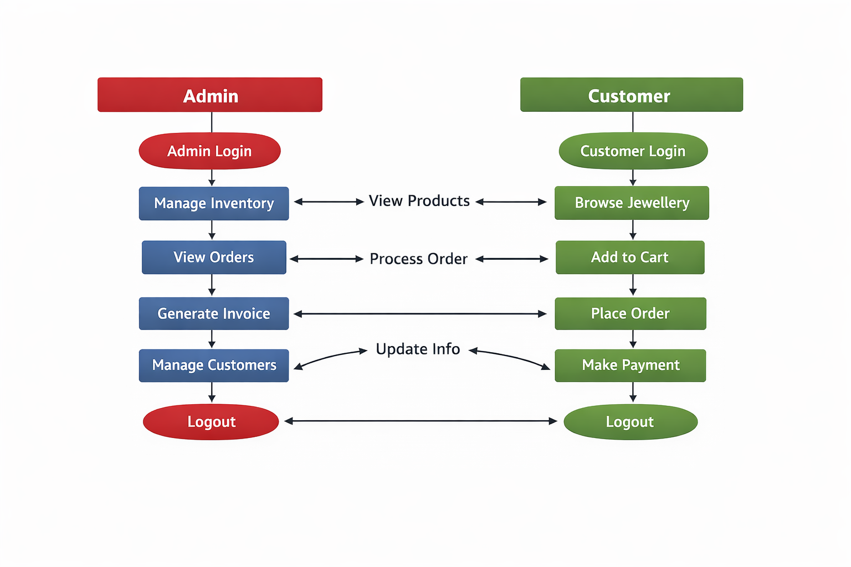

CHAPTER 6
INPUT AND OUTPUT DESIGN

  - ​Input Design

6.1.1Create Account:

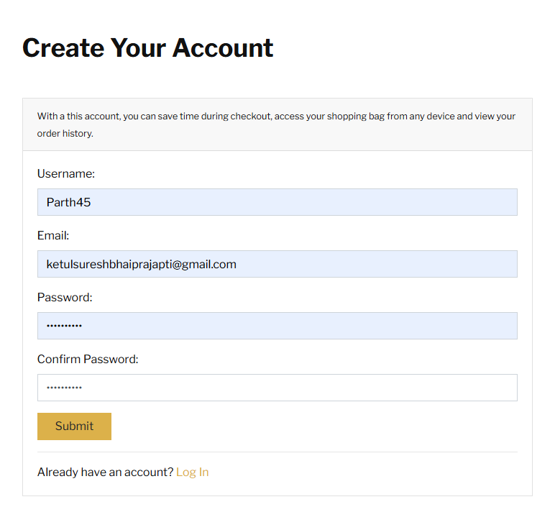

Login
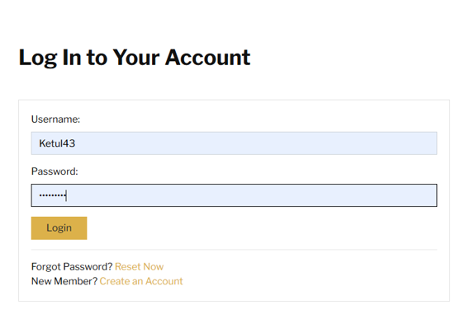

6.1.2 Login Page

6.1.3 Home Page

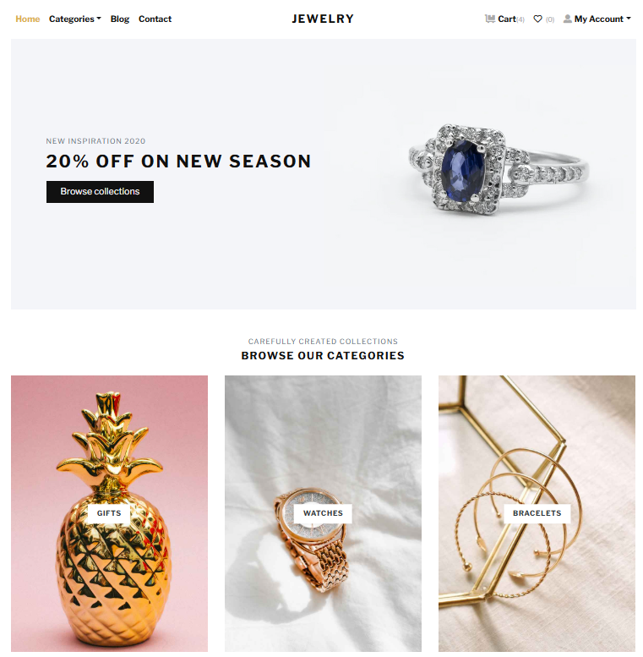

6.1.4 Products Page

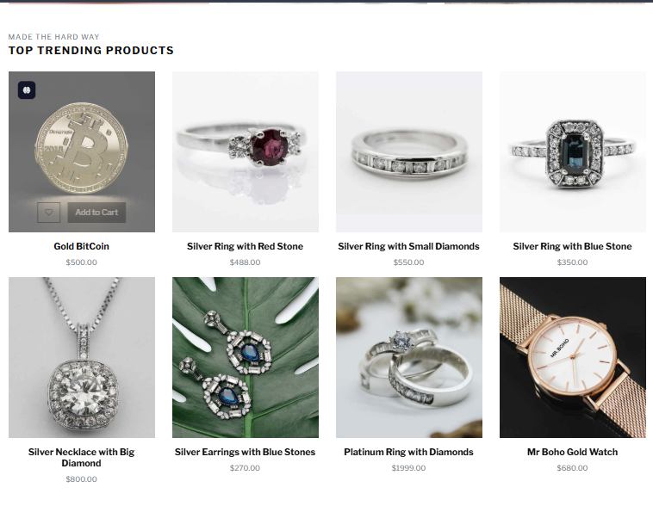

6..1.5 Categories

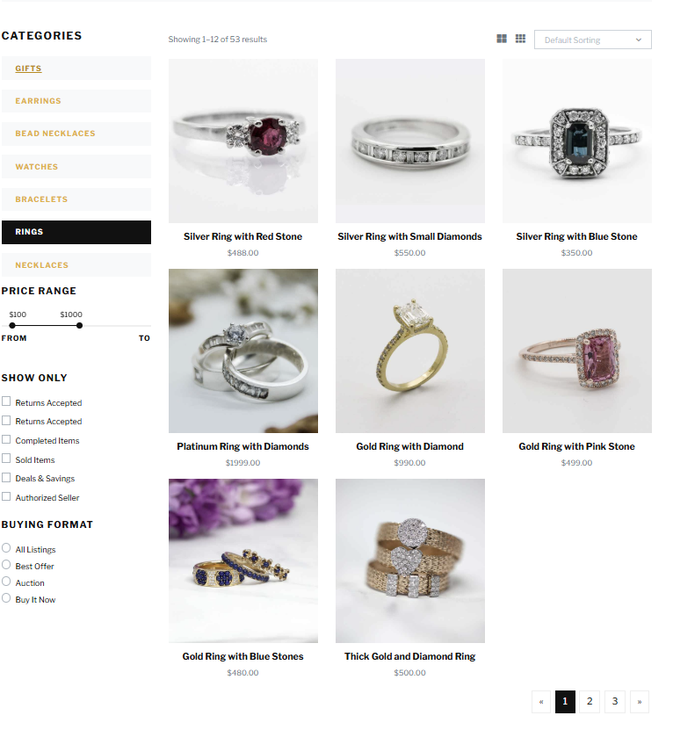
6.1.6 Contect Us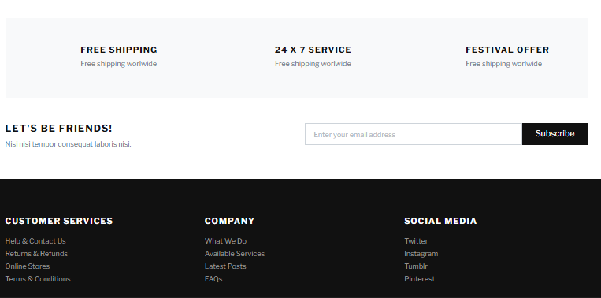

6.1.7 Cart

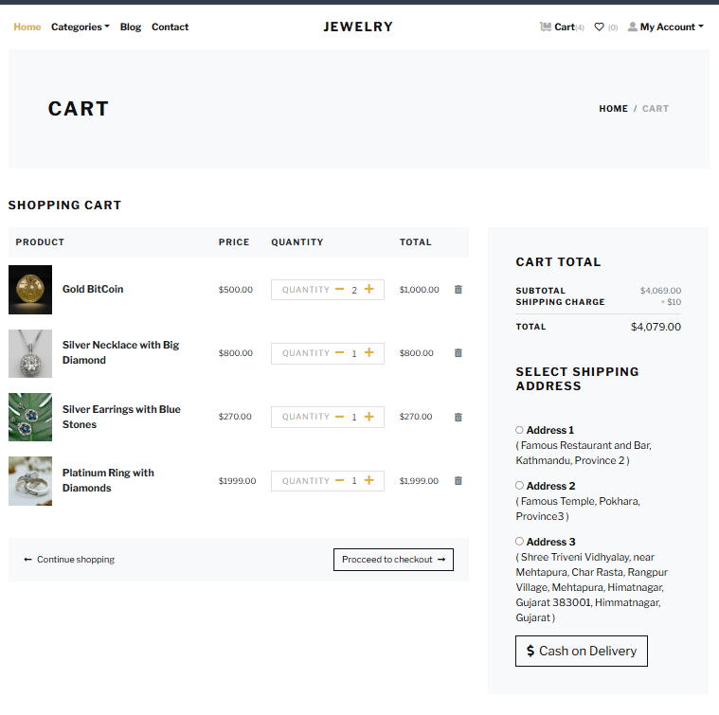

6.1.8 Change Your Passord

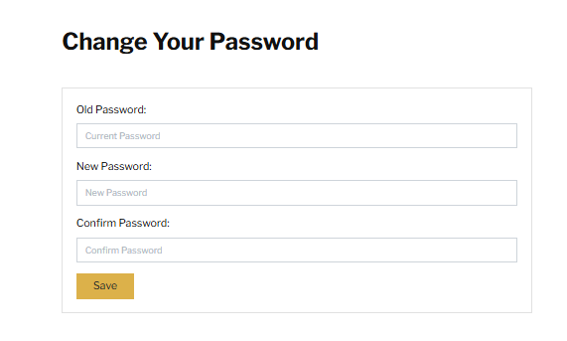

6.1.9 Orders:

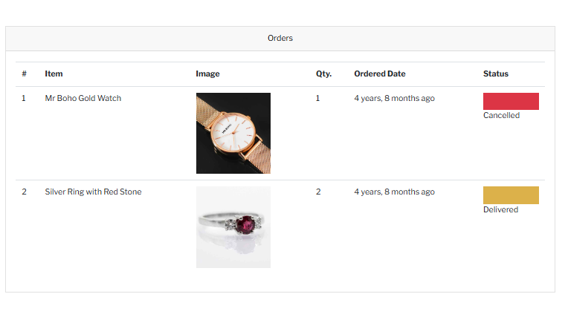
6.1.10Order Details:
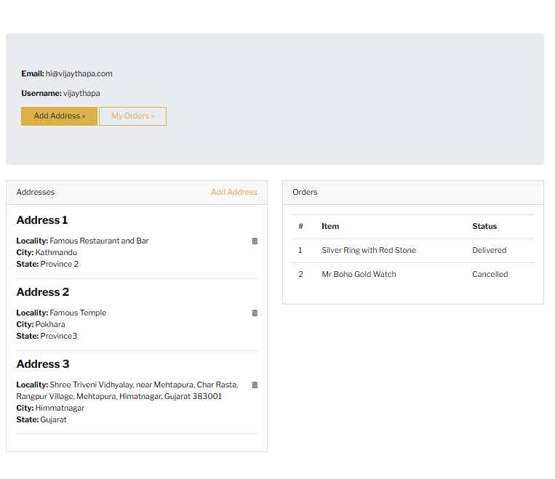

6.1.11 ONLINE PAYMENT

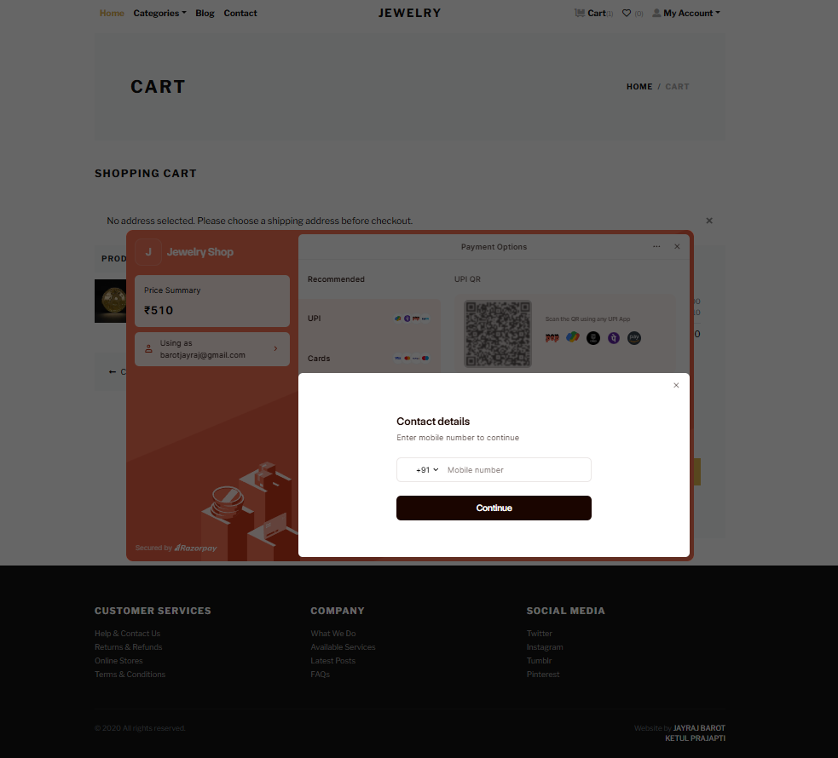

6.1.12 PAYMENT PROCESS

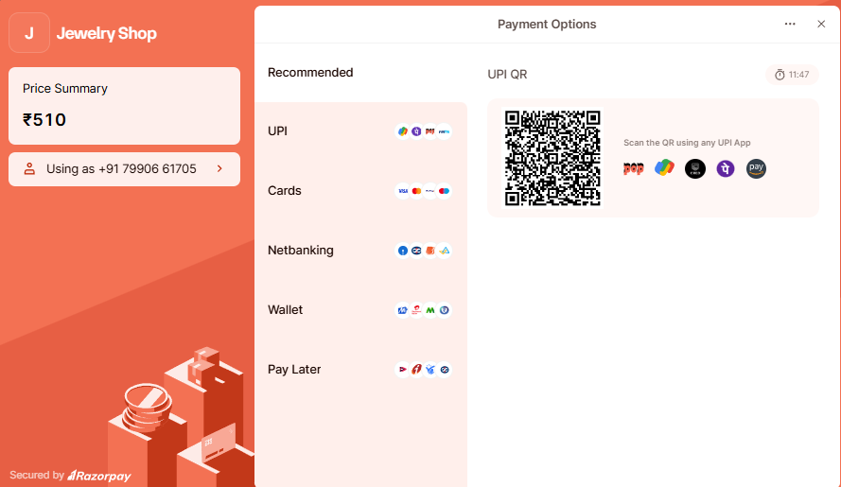

6.1.13 PAYMENT SUCCESSFUL

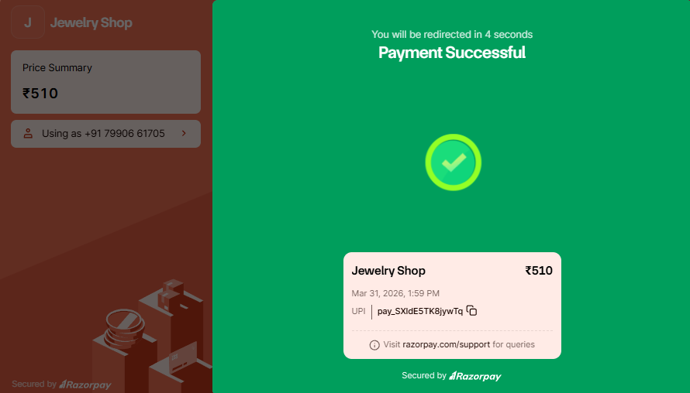

6.1.14 PAYMENT SUCCESSFUL

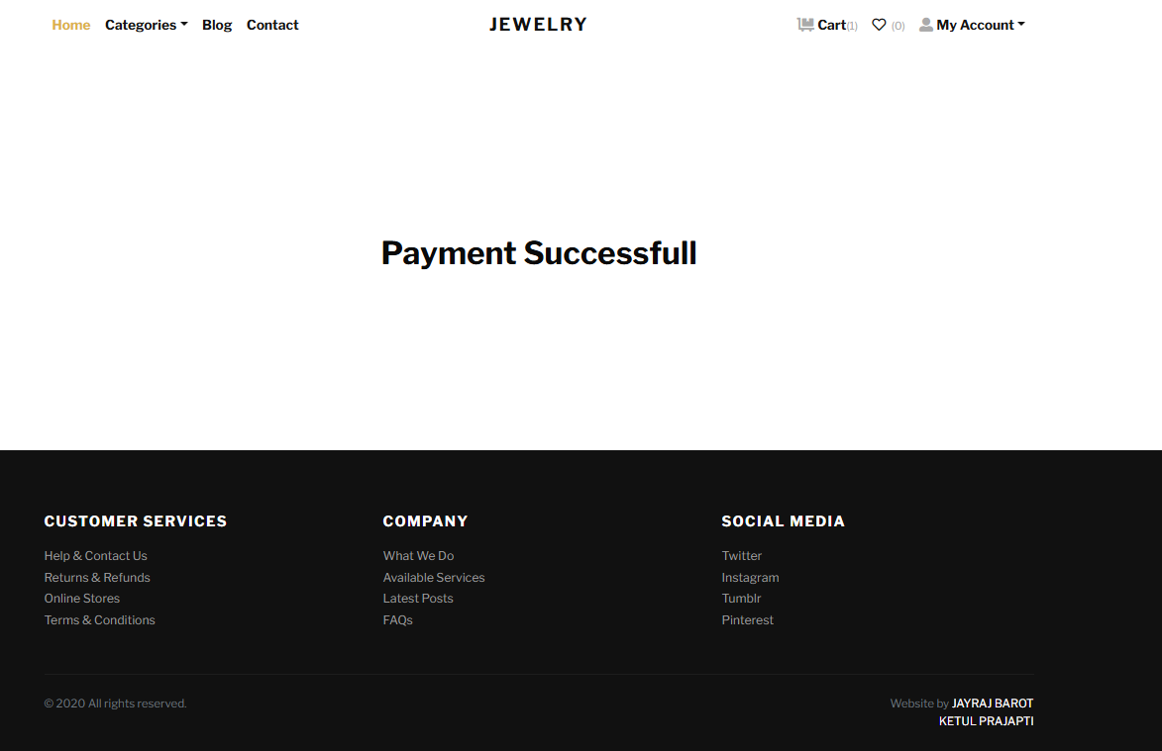

6.1.15ADMIN
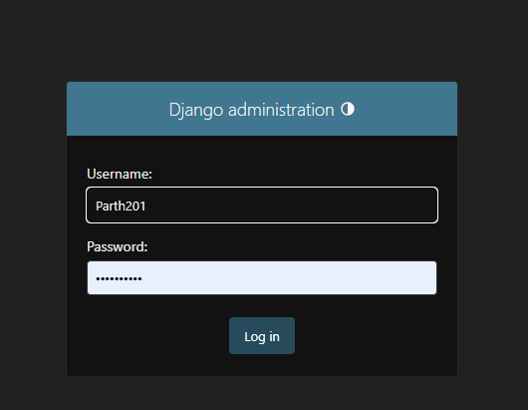

6.1.16 YOUR USERS

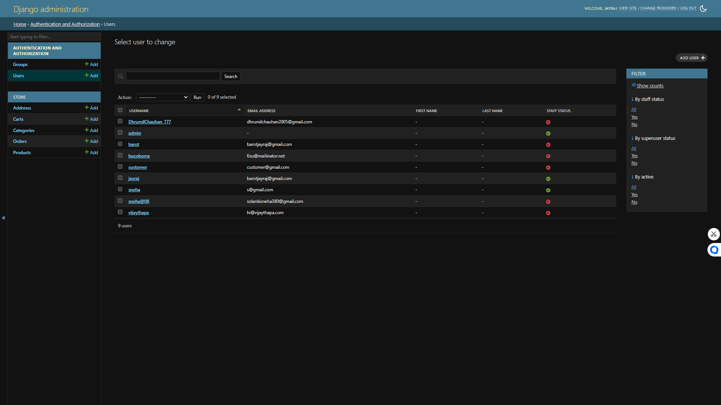

6.1.17 YOUR ADDRESSES
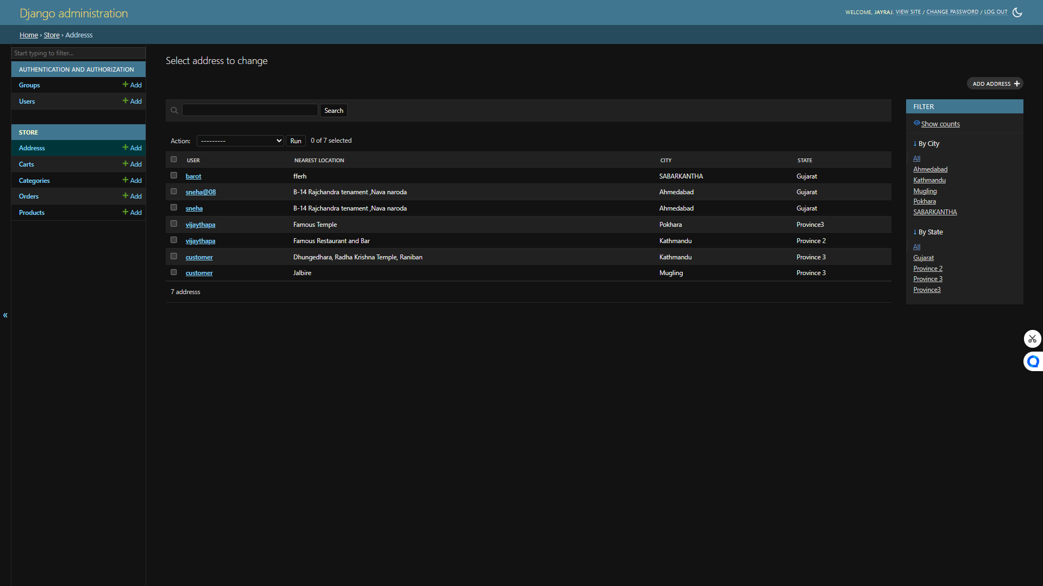

6.1.18 YOUR CARTS

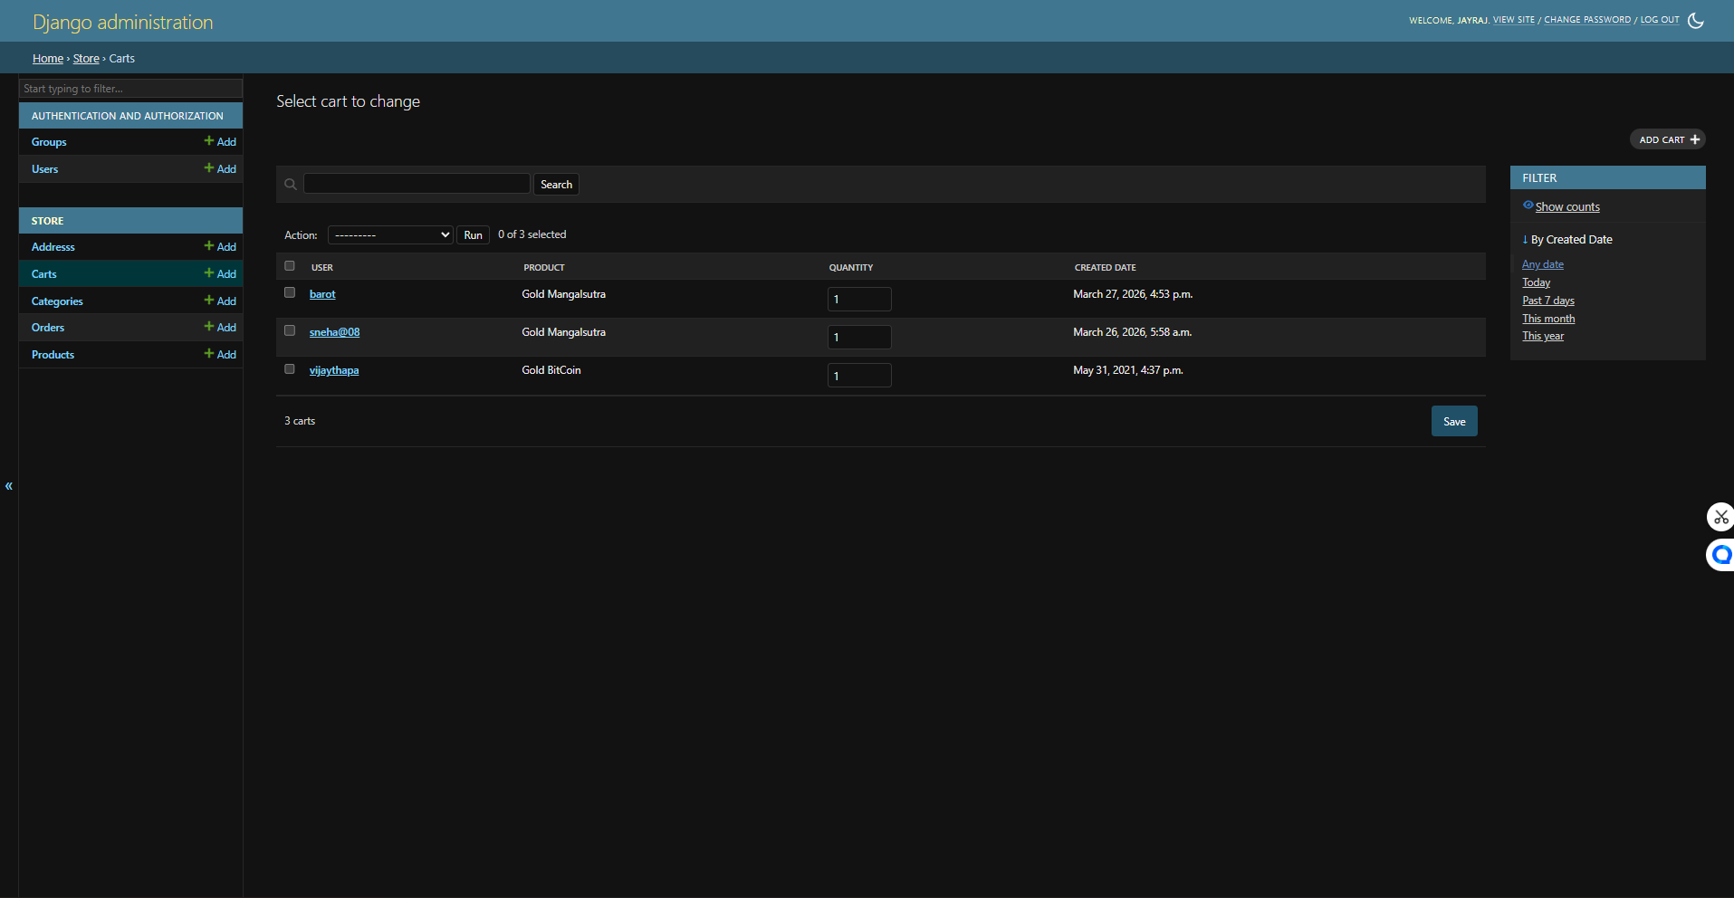

6.1.19 YOUR CATEGORY

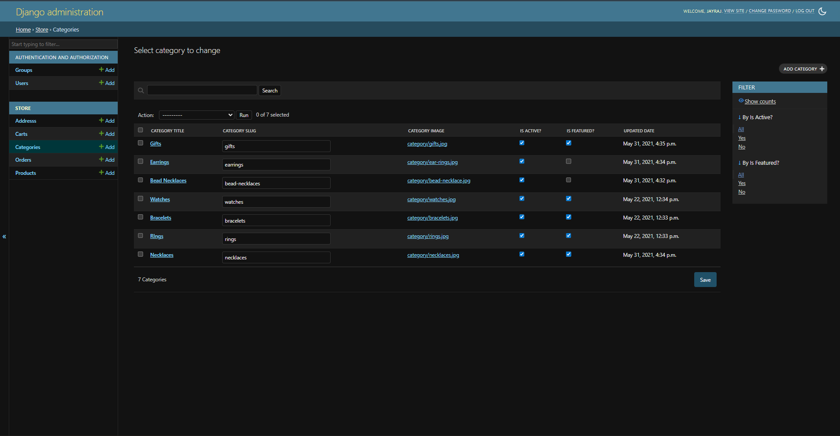

6.1.20 YOUR ORDERS

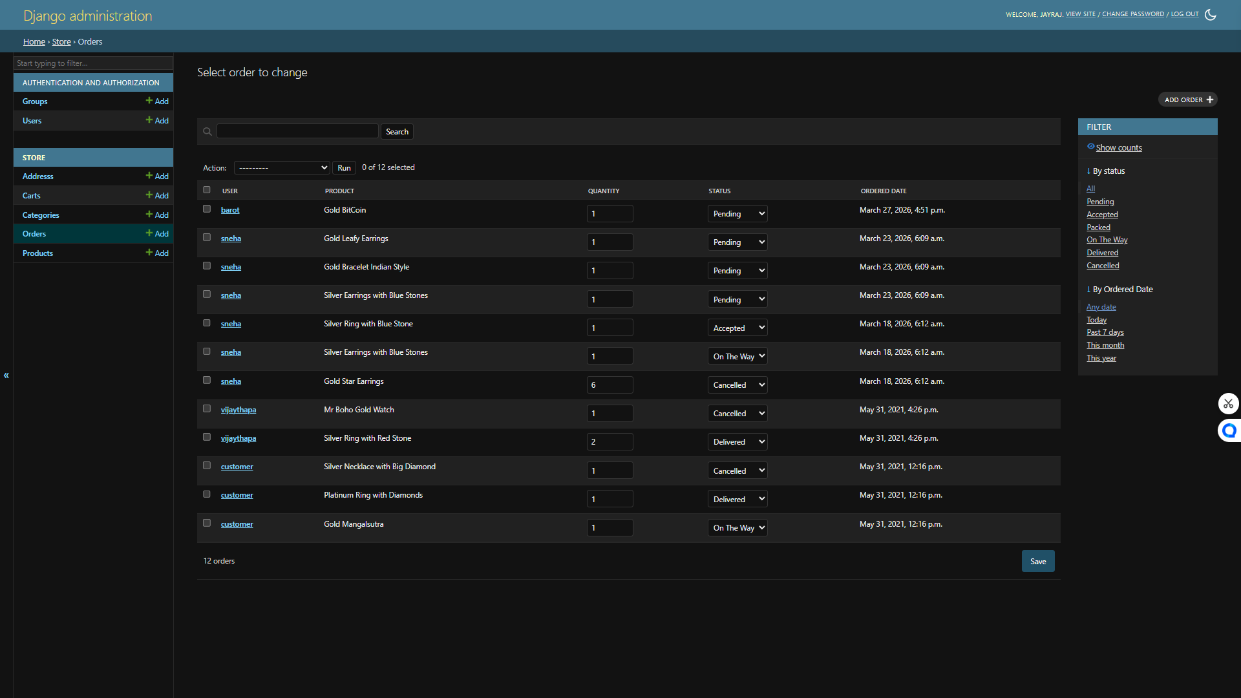

6.1.21 YOUR PRODUCTS

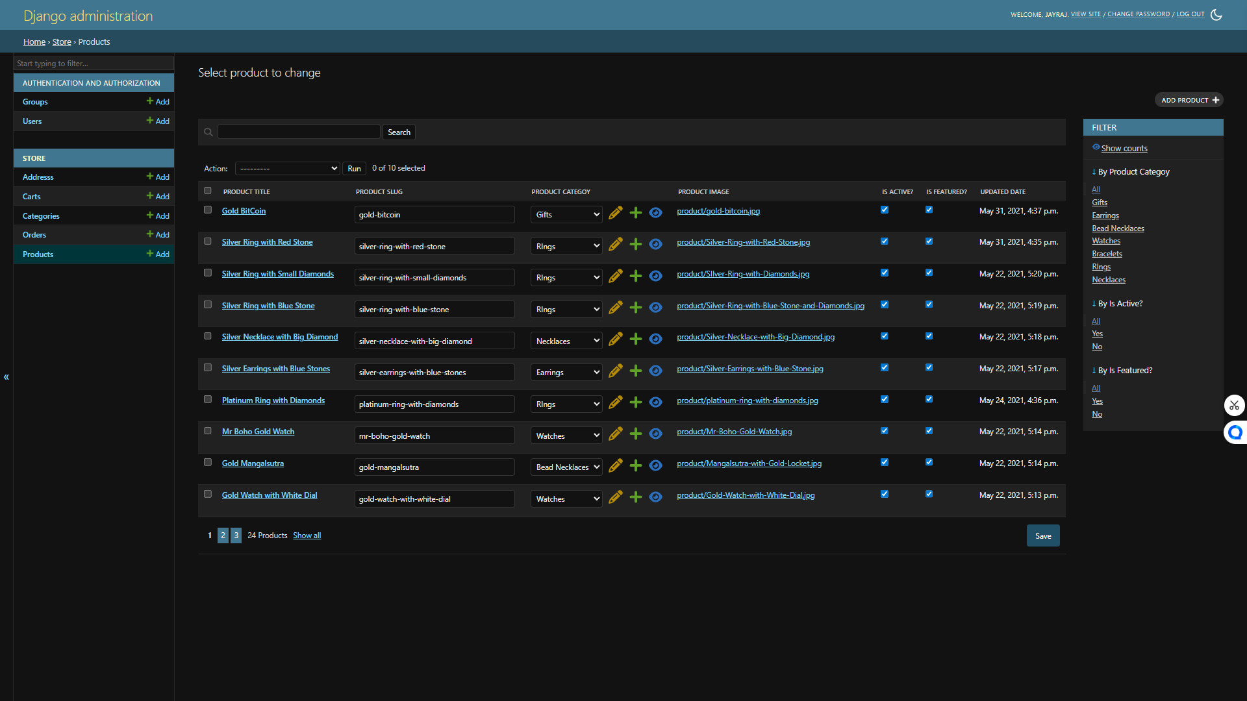

CHAPTER7
IMPLEMENTATION METHODOLOGY

  - ​Front-end Description

HTML (Hypertext Markup Language)
HTML is used to structure the web pages of the College Management System. It defines elements such as forms, tables, buttons, and text content used in pages like login, registration, dashboard, and student details.

CSS (Cascading Style Sheets)
CSS is used to style the HTML elements and improve the visual appearance of the system. It helps in designing layouts, colours, fonts, spacing, and responsiveness of the application.

JavaScript (JS)
JavaScript is used to make the web pages interactive and dynamic. It handles client-side validations, form submissions, and user interactions such as alerts, dynamic content updates, and validations.

Bootstrap
Bootstrap is a front-end framework used to design responsive and mobile-friendly web pages. It provides ready-made components like navigation bars, forms, buttons, and grids, which help in faster development and consistent UI design.

Role of Front-End in College Management System
- Provides user interface for students, faculty, and admin
- Displays forms for login, registration, and data entry
- Shows student records, course details, and results
- Ensures responsive and user-friendly design
- Performs basic client-side validation

7.2 ​Back-end Description

Python
Python is a high-level programming language used to implement the backend logic of the system. It is simple, readable, and efficient for handling data processing and application logic.

Django Framework
Django is a powerful Python web framework used to build secure and scalable web applications. It follows the MVT (Model-View-Template) architecture.
Features of Django in Project:
- Handles URL routing
- Manages business logic
- Provides built-in admin panel
- Ensures security (authentication, CSRF protection)
- Simplifies database operations

SQLite Database
SQLite is a lightweight, file-based database used in this project. It does not require a separate server and is ideal for small to medium-scale applications.
Role of Back-End in College Management Project
- Handles user authentication (login/logout)
- Processes student, faculty, and course data
- Performs CRUD operations (Create, Read, Update, Delete)
- Connects front-end with database
- Manages session and security
- Stores and retrieves data from SQLite database
System Working Flow
- User interacts with HTML/CSS/Bootstrap interface
- JavaScript handles basic validations
- Request is sent to Django (Python backend)
- Django processes the request
- Data is stored/retrieved from SQLite database
- Response is sent back and displayed to user

CHAPTER 8

TESTING AND RESULTS

  - Introduction.

8.1.1 What is testing?
- Software testing is an important part of the software development process that ensures the system works correctly and meets user requirements. In the College Management Project, testing is performed to verify that all modules such as login, signup, and data management function properly without errors.
- It helps in identifying bugs, improving system performance, and ensuring that the application is secure and user-friendly. Proper testing ensures that the system provides accurate results and delivers a smooth experience to students and administrators.

- Why do we need Software Testing?
- Software testing is required in the College Management Project to ensure that the system functions correctly, securely, and efficiently. It helps in identifying errors and improving the overall performance of the system.
- Reasons for Software Testing:

1. Cost Effective
- Testing helps to detect errors in modules like login, signup, and database operations at an early stage, which reduces the cost of fixing them later.

2. Security
- The system stores important data such as student records, staff details, and login credentials. Testing ensures that the data is protected from unauthorized access.

3. Customer Satisfaction
- A well-tested system provides a smooth and error-free experience for users like students and administrators, increasing their satisfaction.
- Principles of Software Testing
Testing is a systematic process used to ensure that the software works correctly. In the College Management Project, testing follows some important principles to improve system quality and performance.

❖ Principles of Software Testing:

1. Testing shows defects
- Testing helps to find errors in modules like login, signup, and database. However, it cannot guarantee that the system is completely error-free.

2. Complete testing is not possible
- It is not possible to test all inputs and scenarios. Therefore, testing is done on important and commonly used features.

3. Early testing
- Testing should start early in development. It helps to find bugs quickly and saves time and cost.

4. Defect clustering
- Most errors are usually found in a few modules such as login or database handling.

5. Testing is context-dependent
- Testing depends on the type of application. In this project, focus is on data accuracy, security, and user management.

6. No software is bug-free
- Even if no errors are found, it does not mean the system is perfect. Continuous improvement is always needed.

8.2Test Cases:

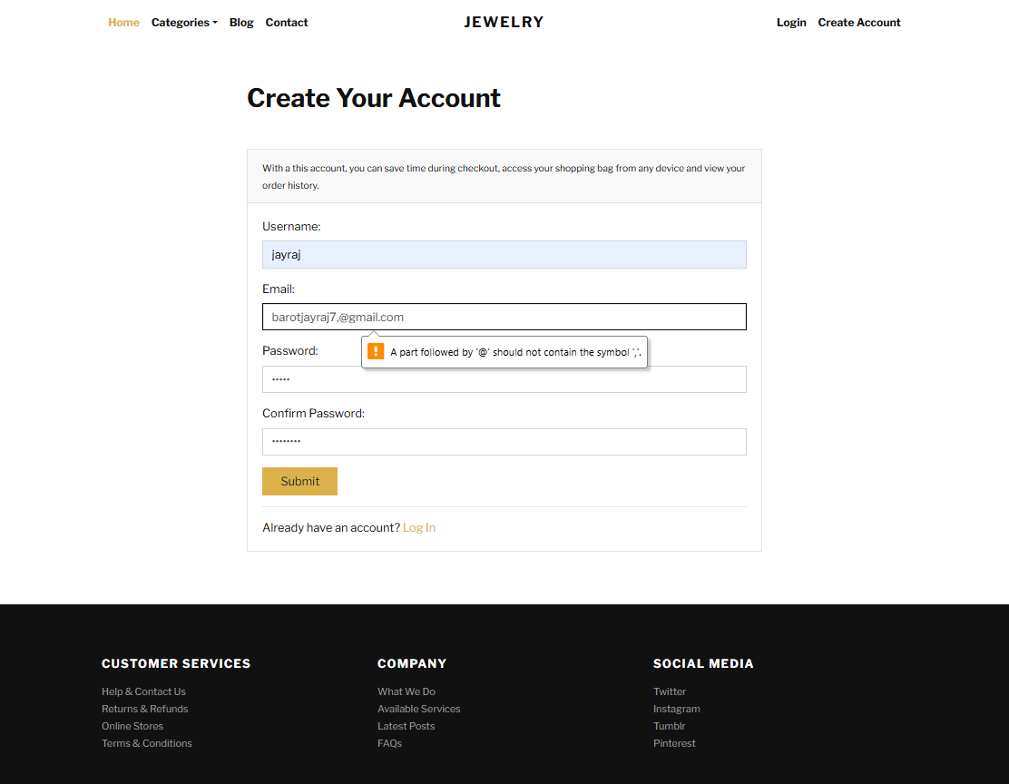

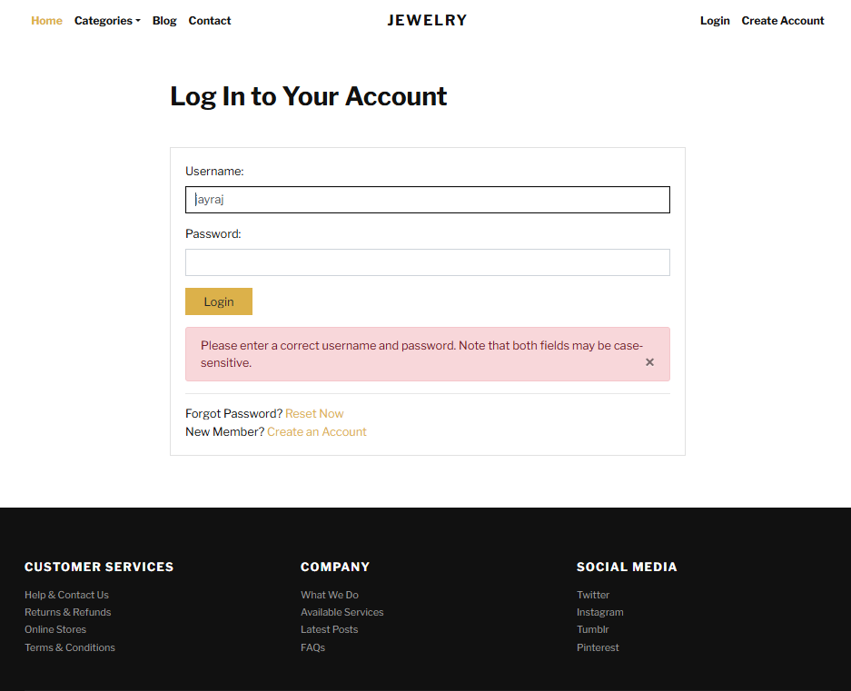

● Login test Case:

Test Case No | Name | Description | Test Data Used | Expected Output | Actual Output | Pass/Fail
1 | Empty Fields Check | System should not allow empty fields | Blank email & password | Error message displayed | Error shown | Pass
2 | Invalid Email Format | Validate email format | abcgmail.com | Enter valid email error | Error shown | Pass
3 | Wrong Password | Incorrect password check | Valid email, wrong password | Login fails | Error shown | Pass
4 | Valid Login | Check correct login | Valid email & password | Redirect to dashboard | Redirected | Pass
5 | Password Format | Check password strength | abc123 | Validation error | Error shown | Pass
6 | Captcha Not Selected | Captcha validation | Valid data without captcha | Captcha error | Error shown | Pass
7 | Captcha Expired | Expired captcha check | Expired captcha | Captcha expired message | Error shown | Pass
8 | Remember Me | Session persistence | Valid login + remember me | User stays logged in | Working | Pass
9 | Forgot Password | Reset link check | Click link | Redirect to reset page | Redirected | Pass
10 | SQL Injection | Security test | Email: ' OR 1=1-- | Login fails | Access denied | Pass
11 | Valid Signup | Valid registration | Valid details | Account created | Redirected | Pass
12 | Password Mismatch | Mismatch check | Pass: 123, Confirm: 456 | Error shown | Error shown | Pass
13 | Duplicate Email | Existing email check | Existing email | Error shown | Error shown | Pass
14 | Blank Fields | Empty fields validation | Blank inputs | Error shown | Error shown | Pass

CHAPTER 9

LIMITATION AND FUTURE SCOPE

  - ​Limitation
- The system uses SQLite database, which is not suitable for large-scale and high-performance applications.
- Unfortunate network loss while online website can leave from website.

  - ​Future Scope
- Upgrade database to MySQL or PostgreSQL for better scalability and performance.
- Implement RESTful APIs using Django REST Framework (DRF) for integration with mobile and third-party applications.
- Develop a mobile application (Android/iOS) for students and staff access.
- Add advanced authentication systems like JWT, OAuth, and multi-factor authentication.
- Deploy the system on cloud platforms (AWS, Azure, Google Cloud) for global accessibility.
- Implement real-time notifications using WebSockets (for alerts, updates, announcements).
- Enhance UI/UX using modern frontend technologies like React.js or Angular.
- Integrate online payment gateway for fee management.
- Use caching techniques (Redis/Memcached) to improve performance.
- Introduce data analytics and reporting dashboards for better decision-making.
- Add automated testing (unit and integration testing) for reliability.
- Improve system security with encryption, HTTPS, and secure coding practices.
- Implement role-based access control (RBAC) for better user management.
- Expand system to support multiple colleges or campuses (multi-tenant architecture).
- Integrate with biometric or RFID attendance systems.

CHAPTER 10

CONCLUSION

- ​Conclusion
- The College Management Project developed using Python and Django provides an efficient platform for managing academic and administrative tasks. It reduces manual effort, improves data accuracy, and enhances overall system efficiency.
- Although the system has some limitations, it offers a strong base for further development. With future improvements like cloud deployment, modern UI frameworks, and advanced security features, it can be transformed into a scalable and enterprise-level solution.
- Overall, this project demonstrates practical knowledge of web development, database management, and software design, making it a valuable learning experience in the field of Information Technology.

CHAPTER 11
REFERENCES

11.References

  - https://www.w3schools.com
https://getbootstrap.com/
https://docs.djangoproject.com/en/stable/
https://www.sqlite.org/docs.html
  - A Books for Django & Web Development …..
Django for Beginners
Authors
1. William S. Vincent
  - Python Crash Course
Authors
1. Eric Matthes
  - Learning Web Design (HTML, CSS, JS)
Authors
1. Jennifer Robbins



Thank You

